**Project/Activity Name:** Calculator App

**Submitted By:** Ace Lawrence Clavano

**Description:** I built a calculator that allows users to solve simple arithmetic operations, store memory and calculate the stored value in that memory as well, can clear the recent stored calculations, use decimal points and an additional feature that can calculate binary information.

**Source Codes:**

1. **index.html**

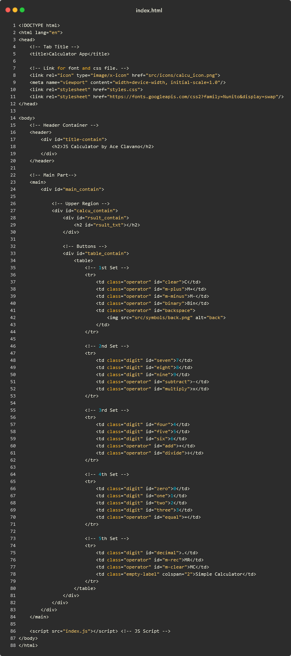



1. **styles.css**

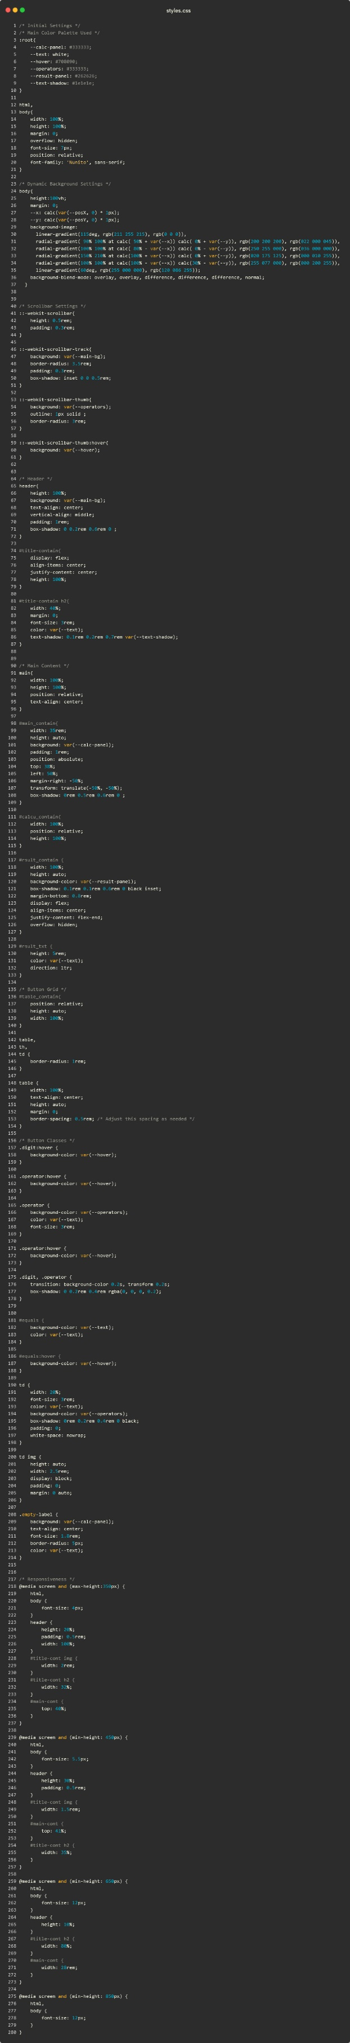

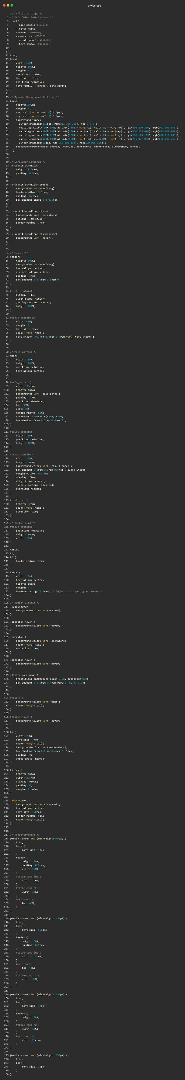





1. 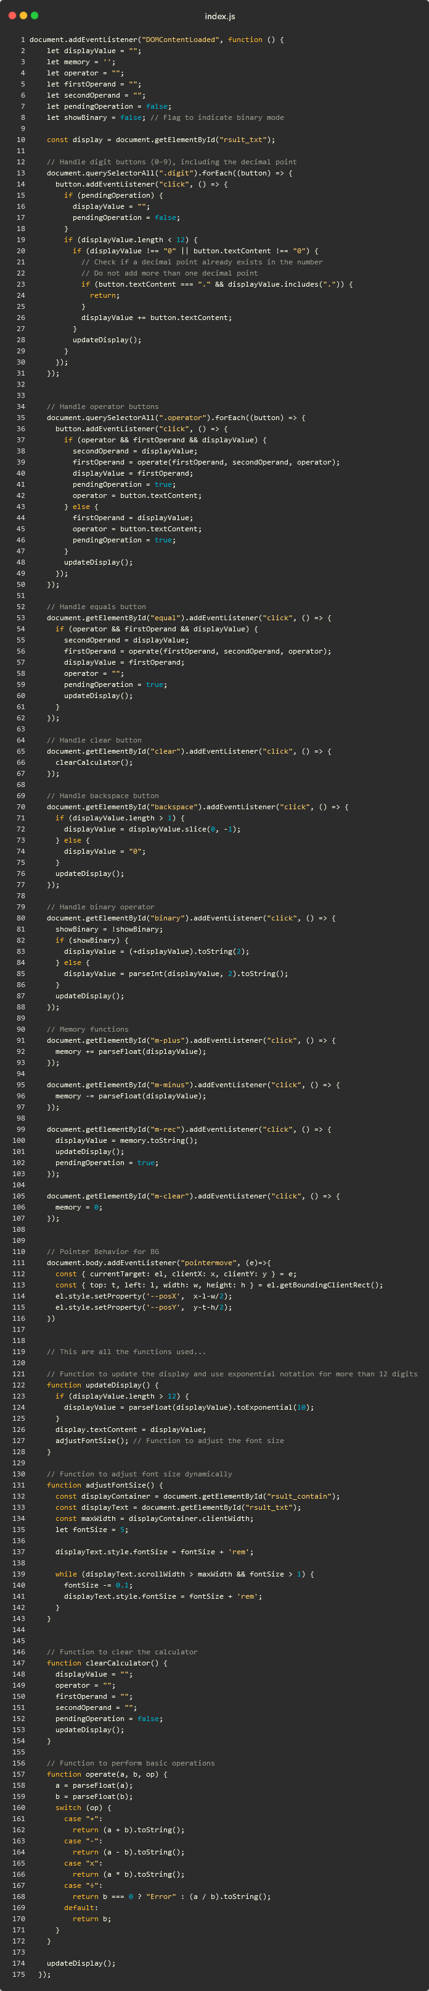**index.js**

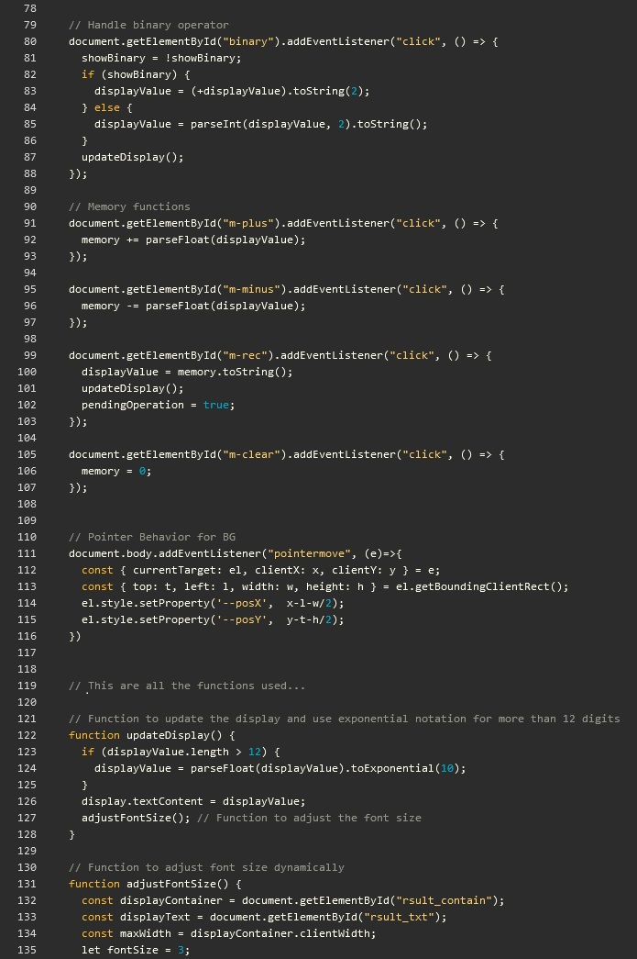

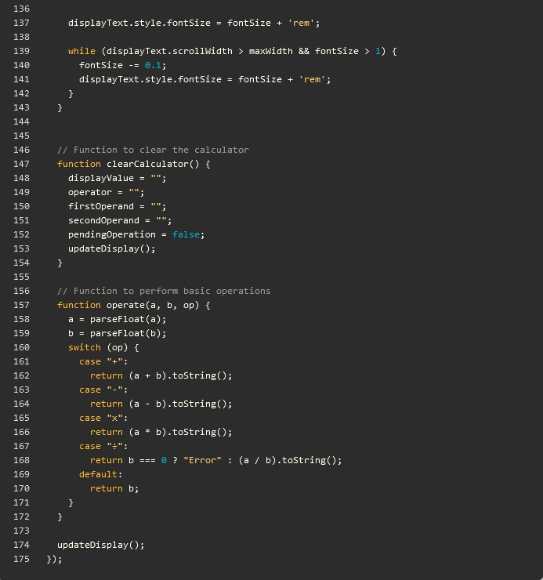

1. **Interface**

